Why is device type blank?

The Citrix XenApp & XenDesktop Client Report allows admins to view details on how end users are connecting to Citrix. The information provided includes Client Name, Client Address, Device Type, and more.

If there is no data for the metric "Device Type", this means that there was not a connected Goliath Intelligent Agent on the XenApp Server/VDI during the course of the end users sessions. In the search bar above, enter the term "agent" for articles on how to install the Goliath Intelligent Agent.

Figure 1 - Report with Missing Data

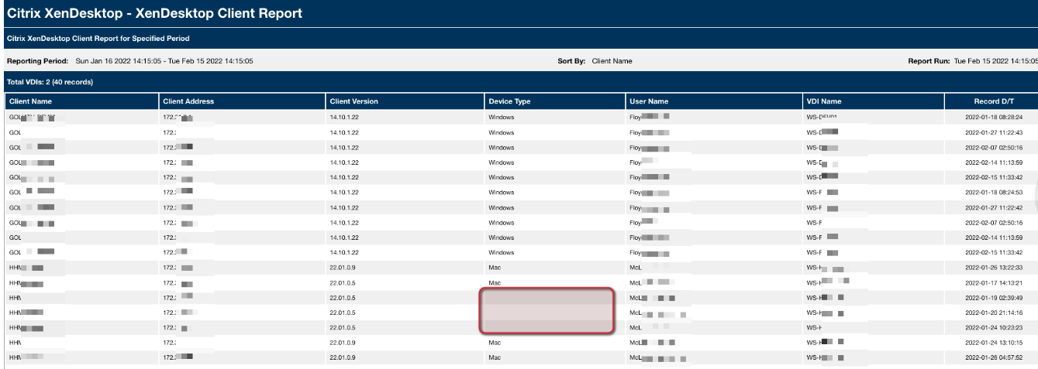

Figure 2 - Fully Populated Report

